Curriculum Vita

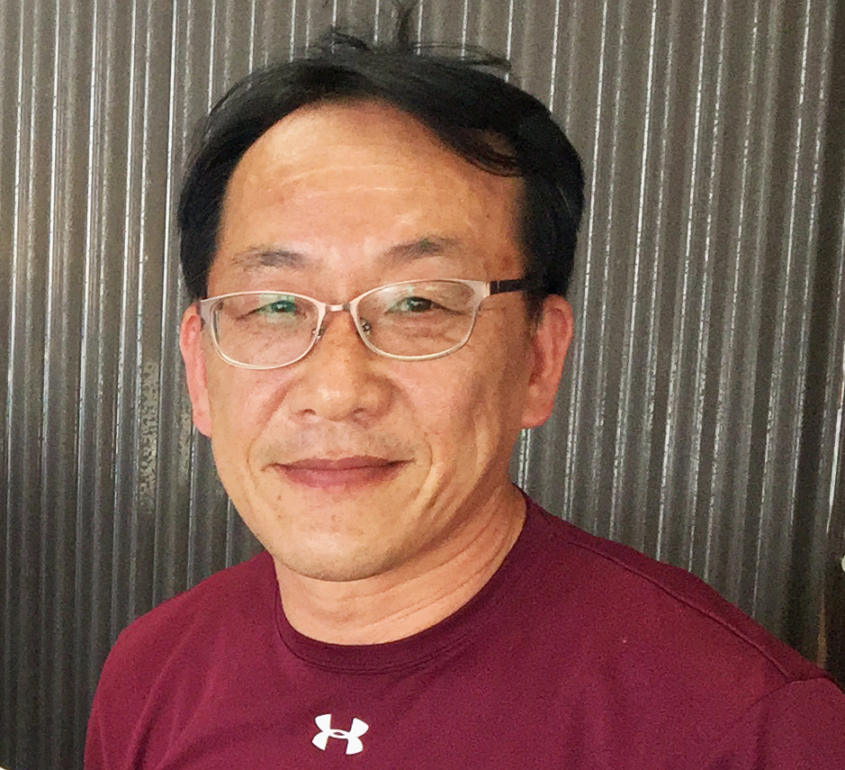 | Name: | Choi, Kwang-Sik (Albert)
 | Date of Birth: | March 25 1961
 | Citizenship: | Republic of Korea
 | Degree hold: | MS, Ph.D. (Dept. Oceanography, Texas A&M University, College Station, USA)
 | Current Title: | Professor  School of Marine Biomedical Science, Jeju National University,  102 Jejudaehakno, Jeju, 690-756, Korea
 | Contact: | e-mail: skchoi@jejunu.ac.kr  phone: 82-64-754-3422  FAX: 82-64-756-3493  Mobile Phone: 010-3699-9000

RESEARCH AREAS: Marine Ecology, Shellfish Reproductive Biology, Pathology of Marine Mollusks, Marine Environmental Ecology

EDUCATION
1979 – 1983 B.S., Oceanography, In-Ha University, Inchon, Korea
1985 – 1987 M.S., Oceanography, Texas A&M University, College Station, Texas, USA (Advisor: Dr. T.J Bright)
1988 – 1992 Ph.D., Oceanography, Texas A&M University, College Station, Texas, USA (Advisor: Dr. E.N. Powell)

EXPERIENCE
1992 – 1993 Post-Doctoral Research Assistant, Dept. Oceanography, Texas A&M University (Dr. E.N. Powell’s laboratory)
1993 – 1995 Senior Research Scientist, Korea Institute of Nuclear Safety
1995 – 2006 Full-Time Lecturer, Assistant and Associate Professor, School of Applied Marine Science, College of Ocean Science, Jeju National University
2006 – Present Professor, School of Applied Marine Science, Jeju National University
2005 – 2006 Associate Dean of Academic Affairs
Vice-Director of the Office of International Affairs
2007 – 2008 Vice-Dean of Graduate Studies

2009 Dean of Graduate School, Jeju National University
2012-2013 Director, Korea Basic Science Institute, Jeju Center

Professional Membership and Career

- 2008 Program Committee Chair for World Aquaculture Society Annual Meeting, Busan Korea
- 2009; Organizing Committee Chair, International Congress of Medical and Applied Malacology (ICMAM), 9th Conference in BUSAN,
- 2009; Organizing chair of Korea-Thailand Joint symposium on "Trend of Research on Marine Environment, Fisheries and Aquaculture" (held in Jeju)
- 2012-2013 President of the Korean Malacological Society
- 2014-2015 President of Aquaculture Chapter, Korean Society of Fisheries and Aquatic Science
- 2015 World Aquaculture Society Annual Meeting co-chair of the Steering Committee, Jeju Korea
- 2015 International Abalone Symposium, Yeosu Korea, co-chair of the Steering Committee

- Member of World Aquaculture Society, since 1992
- Member of National Shellfish Association, since 1987
- Member of Asian Fisheries Society, since 2001
- Member of Korean Aquaculture Society, since 1995

Recent Publications (2013-2015)
Limpanont Yanin, Hyun-Sil Kang, Hyun-Ki Hong, Hee-Do Jeung, Bong-Kyu Kim, Thanh Cuong Le, Young-Ok Kim, Kwang-Sik Choi 2013. Molecular and histological identification of Marteilioides infection in Suminoe Oyster Crassostrea ariakensis, Manila Clam Ruditapes philippinarum and Paciﬁc Oyster Crassostrea gigas on the south coast of Korea. Journal of Invertebrate Pathology 114: 277-284.
Hyun-Ki Hong, Hyun-Sil Kang, Thanh Cuong Le, Kwang-Sik Choi 2013. Comparative study on the hemocytes of subtropical oysters Saccostrea kegaki (Torigoe & Inaba, 1981), Ostrea circumpicta (Pilsbry, 1904), and Hyotissa hyotis (Linnaeus, 1758) in Jeju Island, Korea: Morphology and functional aspects. Fish & Shellfish Immunology 35 (2013): 2020-2025.
Kwang-Jae Park, Hyun-Sung Yang, Hee-Do Jeung and Kwang-Sik Choi 2013. Pathologic condition of the stranded Manila clam Ruditapes philippinarum by storm-originated sediment erosion in spring 2007 in Incheon Bay off the west coast of Korea. Korean J. Malacol 29 (2): 147-154. (in Korean with English abstract)
Hee-Jung Lee, Hyun-Sil Kang, Hee-Do Jeung, Hyun-Ki Hong and Kwang-Sik Choi 2013. First observation on the early embryonic and larval development of spiny oster Saccostrea kegaki Torigoe & Inaba, 1981 (Bivalvia: Ostreoida) using scanning electron microscope on the north coast of Jeju, Korea. Korean J. Malacol. 29 (2): 97-103. (in Korean with English abstract)
Ronald G. Noseworthy, Hee-Jung Lee, and Kwang-Sik Choi. 2013. The occurrence of Clithon retropictus (v. Martens, 1879) (Gastropoda: Neritidae) in an unusual habitat, northern Jeju Island, Republic of Korea. Ocean Science Journal 38 (3): 259-262.
Jee-Youn Lee, Hyun-Sung Yang, Do-Hyung Kang, Hee-Do Jeung, Hyun-Ki Hong, Hee-Jung Lee, Hyun-Sil Kang and Kwang-Sik Choi 2014. Spatial variation in the annual reproductive cycle of Turbo (Batillus) cornutus (Gastropoda: Trochidae) at Jeju Island, Korea, Invertebrate Reproduction & Development, 58:1, 23-33.
Min Jeong Baek, Young-Jae Lee, Kwang-Sik Choi, Won Chan Lee, Hyun Je Park, Jung Hyun Kwak, Chang-Keun Kang 2014. Physiological disturbance of the Manila clam, Ruditapes philippinarum, by altered environmental conditions in a tidal flat on the west coast of Korea. Marine Pollution Bulletin 78 (2014) 137-145.
Hee-Jung Lee, Ronald G. Noseworthy, SangRul Park, Hyun-Ki Hong, Byung-Gul Lee and Kwang-Sik Choi 2014. Report on the molluscan fauna in Tongbatarl lagoon on the east coast of Jeju, Korea. Korean J. Malcol. 30 (1): 95-99. (in Korean with English abstract)
Hee-Do Jeung, Do-Hyung Kang, Heung-Sik Park, Gilles Le Moullac, Kwang-Sik Choi 2014. Quantification of eggs and sperm in the black-lip pearl oyster Pinctada margaritifera using an enzyme-linked immunosorbent assay (ELISA). Fisheries Science (2014) 80: 451-462.
Kaoru Sugihara, Hiroya Yamano, Kwang-Sik Choi, and Kiseong Hyeong 2014. Chapter 6. Zooxanthellate scleractinian corals of Jeju Island, Republic of Korea. In: Nakano, S., Yahara, T. and Nakashizuka, T. (eds), Integrative observations and assessments. Ecological Research Monographs, Springer, Japan, p 111-130.
Hyun-Ki Hong, Ludovic Donaghy, Kwang-Sik Choi. 2014. Flow cytometric studies on the morphology and immunological functions of hemocytes in the Iwagaki oyster Crassostrea nippona. Fisheries Science 80: 969-976.
Hyun-Ki Hong, Ludovic Donaghy, Heung-Sik Park and Kwang-Sik Choi. 2014. Influence of reproductive condition of the Manila clam Ruditapes philippinarum on hemocyte parameters during early post-spawning period. Aquaculture 434: 241-248.
Noseworthy, R.G., Lee, H.-J., Kang, Y.-C., Jung, S., Cha, H.-K., Choi, K.-S. 2014. First report of Cryptoplex proprior Is. And Iw. Taki, 1930. Nautilus 129-134.
Itoh, N., Yamamoto, T., Kang, H.-S., Choi, K.-S., Gree, T.J., Carrasco, N., Awaji, M., Cho, S. 2014. A novel Paramyxean parasite, Martelia granula sp. nov. (Cercozoa), from the digestive gland of Manila clam Ruditapes philippinarum in Japan. Fish Pathology 49 (4): 181-193.
Christophe Vieira, Shashank Keshavmurthy, Se-Jong Ju, Kiseong Hyeong, Inah Seo, Chang-Keun Kang, Hyun-Ki Hong, Chaolun Allen Chen and Kwang-Sik Choi. 2015. Population dynamics of a high-latitude coral Alveopora japonica Eguichi from Jeju Island, off the southern coast of Korea. Marine and Freshwater Research, http://dx.doi.org/10.1071/MF14330.
Donaghy, L., Hong, H.-K., Jauzein, C., Choi, K.-S. 2015. The known and unknown sources of reactive oxygen and nitrogen species in haemocytes of marine bivalve molluscs. Fish and Shellfish Immunology 42: 91-97.
Han, E., Park, H.-J., Bergamino, L., Choi, K.-S., Choy, E.-J., Yu, O.-H., Lee, T.-W., Park, H.-S., Shim, W.-J., Kang, C.-K. 2015. Stable isotope analysis of newly established macrofaunal food web 1.5 years after the Hebei Spirit oil spill. Marine Pollution Bulletin 90: 167-180.
Kang, H.-S., Hong, H.-K., Yang, H.-S., Park, K.-I., Lee, T.-K., Kim, Y.-O., Choi, K.-S. 2015. Spatial variation in the reproductive effort of Manila clam Ruditapes philippinarum during spawning and effects of the protozoan parasite Perkinsus olseni infection on the reproductive effort. Ocean and Polar Research 37: 49-59 (in Korean with English abstract).
Yang, H.-S., Hong, H.-K., Donaghy, L., Noh, C.-H., Park, H.-S., Kim, D.-S., Choi, K.-S. 2015. Morphology and immune-related activities of hemocytes of the mussel Mytilus coruscus (Gould, 1861) from East Sea of Korea. Ocean Science Journal. 50: 77-85.
Young-Jae Lee, Kwang-Sik Choi, Dae-Sung Lee, Won Chan Lee, Hyun Je Park, Eun Jung Choy, Hyung Chul Kim and Chang-Keun Kang. 2015. The role of the adductive muscle as an energy storage organ in the pen shell Atrina japonica (Reeve, 1858). Journal of Molluscan Studies. Doi:.1093/mollus/eyv025
Thanh Cuong Le, Hyun-Sil Kang, Hyun-Ki Hong, Kwang-Jae Park, Kwang-Sik Choi 2015. First report of Urosporidium sp., a haplosporidian hyperparasite infecting digenean trematode Parvatrema duboisi in Manila clam, Ruditapes philippinarum on the west coast of ZKorea. Journal of Invertebrate Pathology 130: 141-146.
Chang-Keun Kang, Hyun Je Park, Eun Jung Choy, Kwang-Sik Choi, Kangseok Hwang, Jong-Bin Kim. 2015. Linking intertidal and subtidal food webs: consumer-mediated transport of intertidal benthic microalgal carbon. PLOS ONE 10 (10): e0139802. DOI: 10. 1371/journal.pone.0139802 October 8, 2015.
Mostafizur Rahman Mondol, Shashank Keshavmurthy, Hee-Jung Lee, Hyun-Ki Hong, Heung-Sik Park, Sang-Rul Park, Chang-Keun Kang, Kwang-Sik Choi 2015. Recovery of wild Pacific oyster, Crassostrea gigas in terms of reproduction and gametogenesis two-years after the Hebei Spirit oil spill accident off the west coast of Korea. Continental Shelf Research 111: 333-341.
Hyun-Ki Hong, Shashank Keshavmurthy, Chang-Keun Kang, Kangseok Hwang, Sang Rul Park, Sung-Hwan Cho, Kwang-Sik Choi. 2015. Alveopora japonica repopulation of a bare substrate off Jeju Island, Korea. Bulletin of Marine Science 91(4): 477-478.
